NEBRASKA

National History Day

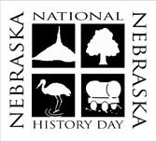

2022 State Contest
Information Guide

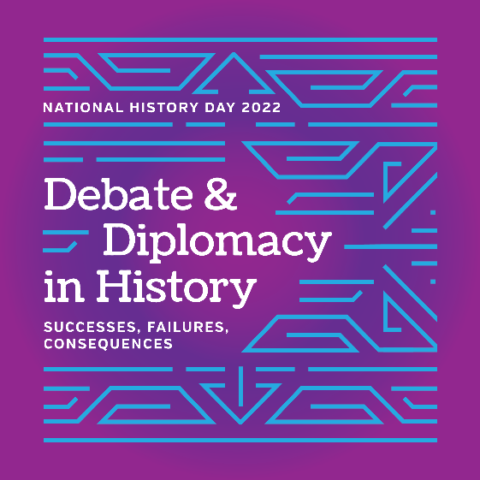

Saturday, April 9, 2022

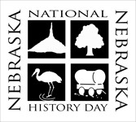

NEBRASKA

National History Day

March 2022

Dear State Qualifier:

Congratulations and welcome to the Nebraska National History Day State Contest! The contest will be held Saturday, April 9, 2022, at Nebraska Wesleyan University in Lincoln. Family, friends, and sponsors are welcome and encouraged to share in the excitement by attending.

This State Contest Information Guide will provide you with an overview of the entire contest. Please read carefully, as it will answer many of your questions. Our website, http://NebraskaNHD.org, is an additional resource for contest information.

Your registration information from the district contests will carry over into the state contests. To confirm state registration, simply log in to the state registration site, verify that all of your information is correct, and generate, print, and send in your invoice with your registration fee. Registration closes on Thursday, March 24, so changes and confirmations need to be completed by that date.

The preliminary interview schedule will be given to your teacher approximately a week before the contest and posted on the website a few days before the contest. All students should arrive for check-in between 7:45 and 8:30 am. If your interview time is before 9:30 am, show up early to register so you are not standing in line when you should be showing off your great research project.

Thanks to a generous grant from the Nebraska Humanities Council and Nebraska Cultural Endowment, our state entry fee is $12.00 per student. Payment is due to Nebraska NHD, Nebraska Wesleyan University, 5000 St. Paul Ave., Lincoln, NE 68504 by Thursday, March 31.

If you have questions, please feel free to get in touch. Our phone numbers are 402-465-2439 and 1-800-541-3818 ext. 2439. You may also e-mail any inquiries to me (swills@nebrwesleyan.edu) or the event coordinator, Shari Sorenson (ssorenso@nebrwesleyan.edu). We will be happy to assist you.

We look forward to seeing you in Lincoln.

Sincerely,
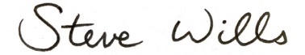

Steve Wills, Associate Professor of History
State Coordinator
Nebraska National History Day

Sponsoring Institution
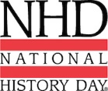
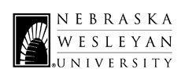
5000 St Paul Ave
Lincoln, NE 68504
Office Phone 402.465.2439
www.nebraskanhd.org

Overview

Nebraska National History Day is affiliated with the National History Day program, which began in 1979. The national office is located near the University of Maryland in College
Park, Maryland. The program is currently held in all 50 states, the District of Columbia, American Samoa, Guam, and U.S. Department of Defense Schools throughout the world.

Nebraska National History Day is divided into seven districts: Hastings, Kearney, Lincoln, Northeast, Omaha, Peru, and Western. Each district invites local students to participate in the district History Day contest. The top three or four winning entries in each category from the district level compete at the state contest, held at Nebraska Wesleyan University. The first and second place entries in each category at the state competition are then invited to participate at the National History Day virtual contest which will occur June 12-18, 2022.

This guide contains information to help teachers, students, and parents register and prepare for the Nebraska National History Day State Contest. Key features of the guide include:

- Deadlines
- Registration/Log-In
- Fee Requirements
- Policies and Procedures
- Schedule of Events

Please refer to the National History Day Contest Rule Book for specific project rules. It can be accessed electronically at:

https://www.nebraskanhd.org/abouthistoryday

Congratulations on submitting a winning entry!

We look forward to seeing you on April 9, 2022
in Lincoln, Nebraska!

Table of Contents

State Contest Deadlines…………………………………………………...………………......6
Cancellation Policy……………………………………………………………………………...6
Registration/Log-In………………………………...……………………………………………7
Student Fee…………………………………………………...…………………………………7
Special Awards Nomination……………………………………………………………………8
Improving Projects………………………………………………………………………………8
Waiving the Interview ………………………………………………………………………….8
Absent Students for Group Entries……………………………………………………………9
Day of the State Competition – Check-In…………………………………………………….9
Judging Locations (Tentative) .……………………...…………………………………….….10
Judging of Student Entries
Historical Papers.……………………………………………………………………....11
Websites..………………………………………………………..……………………...11
Exhibits..………………………………………………………………………..…….....11
Documentaries …………………………………………………………………….…..12
Performances …………………………………………………………..………..…...12
Campus Map.……………………………………………………………………..…………....13
Lost and Found Items…………………………………………………………………….……14
Chaperone Policy………………………………………………………………………….…...14
Technology Policy………………………………………………………………………….…..14
Student Conduct………………………………………………………………………….…….14
Parking……………………………………………………………………………………….….15
Contact Information……………………………………………………………………….……15
FAQs…………………………………………………………………………………..….….16-17
Tentative Contest Schedule………………………………………………………….………..18
Lunch/Snack Options………………………………………………………………….……….19
Sponsor Information ………………………………………………...…….……….…Last Page

State Contest Deadlines

- Friday, March 18, 2022 at 5:00pm CST - CANCELLATIONS DUE
- Thursday, March 24, 2022 at 11:59pm CST - REGISTRATION CLOSES
- Thursday, March 31, 2022 at 5:00pm CST - STUDENT FEES DUE
- Thursday, March 31, at 11:59pm CST – SUBMISSION DEADLINE
AND WEBSITE LOCKOUT
- Saturday, April 9, 2022 at 8:30am CST - EXHIBITS MUST BE SETUP
Students creating exhibits and performances must submit their written work (title page, annotated bibliography, and process paper) by the submission deadline. This written work will be assessed by the judges prior to the presentation of the exhibits and performances on the actual contest date. If students are waiving the interview, the project entry must also be submitted by March 31. Students creating documentaries and historical papers will need to submit their documentary or historical paper in addition to this written work so that the judges may review it before the contest date. Websites will also be locked out on this date. Written work for the research you conducted should be integrated into the project. No additional paper copies need to be brought on the day of the contest, except for your own reference.

Cancellation Policy

Cancellations must be made in writing (email is acceptable format) and received by the Nebraska NHD office (Shari Sorenson, ssorenso@nebrwesleyan.edu) by Friday, March 18. Nebraska National History Day is unable to provide refunds for cancellations after March 24, 2022. For group entries, cancellation is only necessary if all group members are absent. See page 5 for more information about absent group members.

State Registration Openings by District
Student registration will vary from district to district depending on the district contest date. Students will be advanced within 5 business days after the conclusion of their contest date. Students and teachers will receive a registration invite through an automated system. There is only one close date for state registration – Thursday, March 24, 2022.

Registration/Log-In

Must be completed by Thursday, March 24, 2022 at 11:59 p.m. Central Time
Students must log in (option on the upper right of the page) to the state registration and confirm the information entered at the district level, complete permissions and waivers, select payment terms, etc. The username and password will be the same as the district contest. Students can access the link for the state contest through the website’s state contest page (https://www.nebraskanhd.org/statecontest) or https://ne.nhd.org. The link is also available in the advancement notification email. DO NOT CREATE A NEW ACCOUNT.

If a password has been forgotten, there are two options for resetting:
1 –Students can select “Forgot Password” to go through the process of resetting. The student must have entered an email account that does not block outside emails – school systems often block outside emails – in order to get the reset link.
2 – Email NebraskaNHD@gmail.com to have the password reset. A new password will be reset within 48 hours and emailed back.

Remember to access the State Contest, not District, when confirming information and submitting!

Student Fee

$12.00 per student
Checks payable to Nebraska National History Day.
Memo line: Name of student(s)
Student fees are due Thursday, March 31, 2022 5:00pm in the state office.

Send to:
Nebraska Wesleyan University
Nebraska National History Day
Attn. Shari Sorenson
5000 St Paul Ave
Lincoln NE 68504

All students in a group entry are required to pay the student fee whether they plan on attending the contest or not; if the entry is competing, the student’s work is competing. The students listed in a group project cannot change from district to state or from state to nationals.

Special Awards Nomination

Students can nominate an entry through the online registration system; teachers can nominate an entry by clicking on a student listed under “My Students” and selecting the Nomination Tab.

NEBRASKALand Foundation Award:
The NEBRASKALand Foundation Award honors the best entries in both the Junior and Senior Divisions that deal with a person, place, event, institution or other development that contributed to the heritage of Nebraska. Each division award carries a cash prize: $300 for first place and $200 for second place (divided among participants if awarded to a group entry) plus two honorable mentions (no monetary award) in the Junior and Senior Divisions.

The following Awards are automatically awarded to the highest-ranking entry in a specific category:

Nebraska Wesleyan University Award:
Nebraska Wesleyan University will award a $500 scholarship for NWU tuition to the first-place winner of each Senior Individual Category at the State Contest. The scholarship will be honored upon enrolling at Nebraska Wesleyan University.

Michael Berg Memorial Award:
The Michael Berg Memorial Award is given by private donors to the first place of the Senior Individual Documentary in memory of Michael Berg.

Nebraska Press Association Foundation Award:
The Nebraska Press Association Foundation will award $100 to the first place of the Junior and the Senior Division Historical Paper.

Improving Projects

Students are encouraged to review judges’ suggestions from the district contest and consider them when revising their projects for the state contest. Feel free to look at the national website (nhd.org) webinars and google chats for additional guidance. Students should take the time to check their work (project, title page, process paper, and annotated bibliography) for typographical errors and misspellings. These types of errors should not be occurring at the state level. All projects should be polished by the time they reach the state level!

Waiving the Interview
For this year, students have an option to compete virtually by submitting their entire project digitally and waiving the interview in the registration system. Waiving the interview will not affect the ranking of the project, the project is always expected to stand on its own merits.

Absent Students for Group Entries

A replacement student, one who did not compete at the district contest, is not allowed to participate at the state contest for any category. Group projects are allowed to compete without all members present. All group members are still required to submit the student fee (see the student fee section on page 4).

For a live performance category, if a student is unable to attend the state contest, the entry must be redesigned/rewritten to accommodate only the participating students, even if that means a last-minute rescripting is necessary.

Check-In Day of Contest

All students attending in person must check-in at the Nebraska National History Day state contest. If students do not check-in before the scheduled time, they may miss an updated interview time, therefore being counted as a no-show. Sponsoring teachers or parents may not sign in for students – and students may not check-in for other students!
Registration will take place in the Great Hall of the Smith-Curtis Classroom-Administration Building on the Nebraska Wesleyan University campus (see campus map) and will be held from 7:45 to 8:30 a.m. Late check-in will be from 8:30 to 10:00 a.m. at the teacher check-in table. To arrange a later check-in, contact the state office. Lines can be long, students scheduled to be judged before 9:30 a.m. should check-in early! Teachers may sign in near student check-in to receive their teacher gift.

Judging Locations

Each entry will be given an entry number and assigned to a location in one of several buildings on Nebraska Wesleyan’s campus. Teachers will receive a preliminary schedule of their student’s time and location the week before the contest. Judging times will be posted on the Nebraska National History Day website a day or two before the state contest (https://www.nebraskanhd.org), however, last minutes changes sometimes need to be made; therefore, students will receive confirmation of the time and location for their judging when they check-in at the contest.

Tentative Category Locations:

 |  | Exhibit | Performance | Documentary | Website | Paper
Junior | Individual | 111  Acklie Hall | Emerson Hall  Rogers Fine  Arts Center | 320  Smith Curtis | 242  Smith Curtis | 142  Smith Curtis
 | Group | 109  Acklie Hall | Emerson Hall  Rogers Fine  Arts Center | 322  Smith Curtis | 225  Smith Curtis | N/A
Senior | Individual | 211  Acklie Hall | N/A | 103 Callen  Smith Curtis | 218  Old Main | Chapel  Old Main
 | Group | 207  Acklie Hall | Emerson Hall  Rogers Fine  Arts Center | Virtual | 207  Old Main | N/A

Students should report to their judging area at least 15 minutes ahead of their scheduled judging time. It is important that students be quiet and respectful of others who are being judged while they are waiting for their interview. Judges are volunteering their time and talents, be respectful of their observations and contributions.

The week after the contest, judge evaluations will be made available via the online registration system. Students and teachers can access their judge evaluations by logging in to their account and clicking on the “My Evals” tab.

Judging of Entries

For a detailed description of each category and applicable contest rules, as well as basic judging criteria per category refer to the National History Day Contest Rule Book and visit NebraskaNHD.org.

Historical Papers
Paper submission is through the online registration system as a single PDF including the title page, process paper, historical paper, and annotated bibliography and must be done before Thursday, March 31 at 11:59 pm (Central Time). The state office is not responsible for formatting issues with electronic submissions. Historical Paper is a pre-judged category; the judges will read and evaluate the papers prior to contest day. Judges will interview the student and may review all or portions of the paper with the student on the day of the contest. Students should keep copies of their papers for their own records and bring a copy of their paper to the interview for their reference.

Only the judges and student being interviewed are allowed in the interview rooms.

Websites
Students will be able to edit their websites until Thursday, March 31, 2022, at 11:59 pm (Central Time). Website is a pre-judged category, the judges will review and evaluate the website prior to contest day. Judges will interview the student(s) and may review portions of the website with the student(s) on the day of the contest. NWU will have the website available on the instructional equipment in the classroom. The process paper and annotated bibliography must be integrated within the website as cited in Section E7: Required Written Materials (page 35).

Once a presentation begins no one will be allowed to enter or exit the judging room.

Exhibits
For Physical Exhibits – set up the day of the contest
Students may have no assistance from judges, audience, parents, or chaperones with the exhibit set up, take down, or operation of equipment. Students may have assistance in delivering the exhibit to the judging room. Nebraska NHD will provide tables on which to place exhibits and will provide power strips as needed. Students need to provide any other equipment required for their exhibits. Please note in the online registration if the exhibit requires a floor versus table placement and if power is needed. Students in the Exhibit category cannot dress in costume. (See National History Day Rule Book, Rule 12: Costumes.)

Exhibits must be set up by 8:45 a.m. Students should be present at their exhibits 30 minutes prior to and during the judging of their exhibits. Once their exhibit has been judged, students may leave the area. Exhibits must remain in place until 2:30 p.m. Exhibits may be taken down beginning at 2:30 p.m. and must be removed by 4:00 p.m.

Written material (title page, process paper, and annotated bibliography) must be submitted to the online system by Thursday, March 31 at 11:59pm (Central Time).

Only the judges and students being interviewed are allowed in the exhibit area during judging due to noise distraction.

Documentaries
A link to the documentary as well as written materials (title page, process paper, and annotated bibliography) must be submitted through the registration system before Thursday, March 31 at 11:59 pm (Central Time). Documentary is a pre-judged category; the judges will read and evaluate the documentary prior to contest day. Judges will interview the student(s) and may review all or portions of the documentary with the student(s) at the contest. NWU will have the documentary available on the instructional equipment in the classroom.

Once a presentation begins no one will be allowed to enter or exit the judging room.

Performances
Live Performances the day of the contest
Students must provide any equipment or props used in their entries. The setting up and taking down of props may not occur while other students are performing. Students may not have assistance from judges, audience, parents, or chaperones with the performance set-up or take-down or operation of equipment on stage. Students may have assistance in delivering the props to the judging room and onto the stage. Written material (title page, process paper, and annotated bibliography) must be submitted to the online system by Thursday, March 31 at 11:59pm (Central Time).

Recorded Performances submitted in advance of the contest day
Performances should be recorded in one take with no splicing or video editing. A link to the performance as well as written materials (title page, process paper, and annotated bibliography) must be submitted through the registration system before Thursday, March 31 at 11:59 pm (Central Time). You must also agree to waive the interview through the registration system.

Once a presentation begins no one will be allowed to enter or exit the judging room.

Nebraska Wesleyan University Campus Map
http://www.nebrwesleyan.edu/about-nwu/maps-and-directions

The buildings used for the state contest are:
3 Olin Lecture Halls
4 Smith-Curtis Classroom Administration Building
9 Acklie Hall of Science
11 Old Main
13 Roy G. Story Student Center
16 Rogers Center for Fine Arts
Café and Dining Hall
Judge Center
REGISTRATION AND
AWARDS CEREMONY
JR Documentary,
JR Website, JR Paper, and
SR Ind Documentary

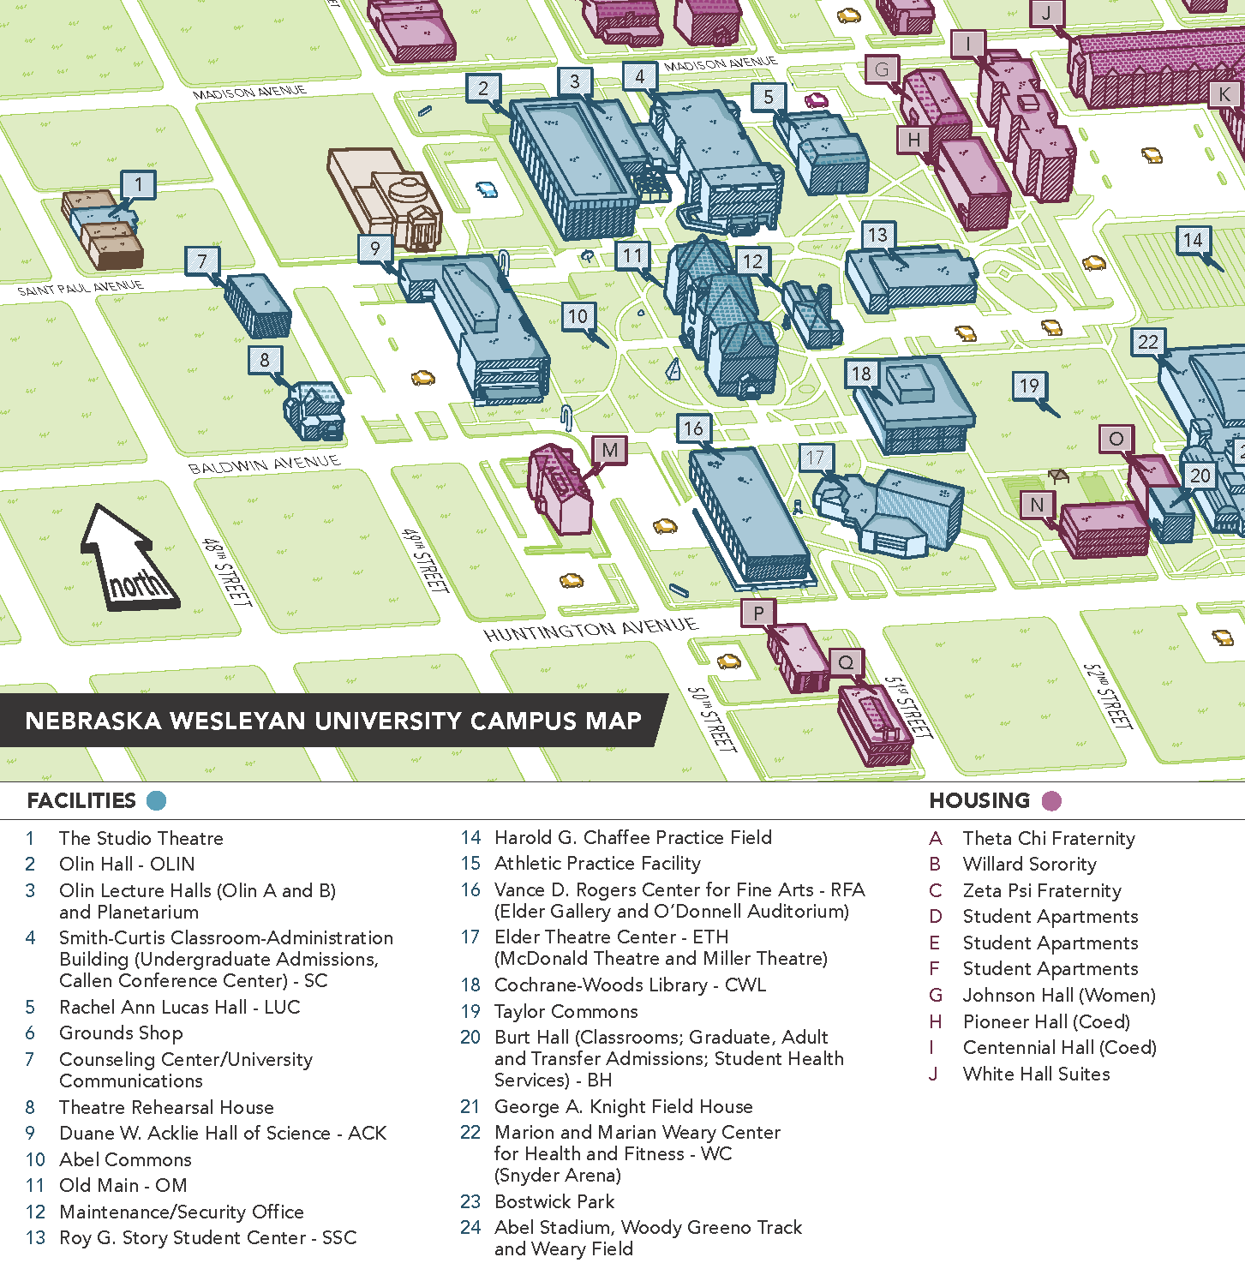

SR Paper and SR Website
Café
JR and SR Exhibits

All Performances
Emerson Hall
(Lower Level)

Lost and Found Items

Nebraska National History Day is not responsible for lost or stolen items, however, each year several items are left behind. Lost items may be claimed by contacting Shari Sorenson at the Nebraska National History Day office at (402) 465-2439 or 1-800-541-3818, ext. 2439 or ssorenso@nebrwesleyan.edu.

Chaperone Policy

All students attending the state contest must be accompanied by an adult chaperone. One chaperone may accompany a group of students. Chaperones are responsible for the behavior of the students in their charge. Large groups should have enough chaperones to be attentive to all members of the group.

Technology Policy

NWU equipment will be used to show documentaries and websites (including large screens, computers, and DVD players). If there is a technical issue, either the judges or student assistants can call for assistance. Please respect the use of Nebraska Wesleyan University equipment (NHD students will be held responsible for any damage).

Student Conduct

As guests of Nebraska National History Day and Nebraska Wesleyan University, students are expected to conduct themselves according to conventions of civility and decency and all rules as set forth in the National History Day Rule Book.

- Students may not possess or use alcoholic beverages or other drugs except those prescribed by a doctor.
- Smoking is prohibited by students and not allowed by adults except in designated areas.
- Students may not abuse, vandalize, or steal any property or service, including exhibits, props, and equipment.
- Students may not possess any weapon, firecrackers, or other flammable materials.
- Students may not physically harm, threaten, or harass any person, including provoking and/or engaging in physical fights or malicious pranks.
- Students must abstain from vulgar, racist, or sexually explicit language or conduct.
- Students may not create excessive noise or disruptions which interfere with the judging of student entries and/or other activities during Nebraska National History Day.

Students who violate stated rules will be subject to disqualification from Nebraska National History Day and cannot represent Nebraska at the national contest at the University of Maryland.

Parking
On-Campus
Students, teachers, and families may park in any campus parking lot except those requiring a blue parking permit. Vehicles may be towed at the owner’s expense if parked in areas posted Loading Zone, Deliveries Only, Fire Lanes, No Parking, or Handicapped Parking (without a Handicapped vehicle permit).

Exhibits can utilize the parking behind Acklie – avoiding blocking the alley or using parking spaces that belong to the apartment complex to the west.

Off-Campus
The City of Lincoln Ordinance prohibits parking within twenty-five feet of an intersection, within five feet of a driveway, and fifteen feet of a fire hydrant.

Questions?

Contact us at:

Nebraska National History Day
Nebraska Wesleyan University
5000 St. Paul Avenue
Lincoln, NE 68504-2794
(402) 465-2439 or 1-800-541-3818, ext. 2439

Shari Sorenson, Event Coordinator
ssorenso@nebrwesleyan.edu

Steve Wills, State Coordinator
swills@nebrwesleyan.edu

Or send us a message through the state website:
https://www.nebraskanhd.org/contact

Please include your name, e-mail address, and your comment or inquiry.

FAQ’s for Students?

Who will I be competing against?
Students from across Nebraska will be competing at the state level. Students, who like you, placed in the top of their category at their District contest.

Can my friends or family come with me on Saturday, the 9th?
Yes! Parents, siblings, grandparents, and friends are all invited and encouraged to be a part of your day. Chaperones are required for those under age 19. You and your family members are encouraged to view other projects with one exception, the Historical Paper category interviews are not open to the public. Due to possible noise interference, the public will be asked to leave the exhibit areas during judging. Public viewing will be during lunch break and after judging has been completed (signs will be posted during public viewing times).

Do I have to stay all day?
No. You do need to check-in at registration before 8:40 am and show up for your interview time (arrive at least 15 minutes before and stay until you have completed your interview). Check with the NWU student assistant at the door if your name has not been called and it is 10 minutes past your scheduled time. You are not required to stay for the Awards Ceremony.

I have a conflict that day, can I just submit my entry?
Although we encourage you to be present so you can meet the judges and view other projects, this year anyone can opt for virtual participation. You will need to check the box in registration that states you are waiving the interview and the reason why. This needs to be completed by March 24 at the latest ( we encourage you to make this decision earlier) and cannot be changed.

The contest is the same day as the FBLA, or I have a sports practice that morning, or the school prom is that night, can I request what time I interview?
The vast majority of interviews will occur between 8:40am and 11:00 am. You may make an “early or late” request in your registration and best efforts will be made to accommodate.

One of the students in my group performance is sick, can a friend step in?
Only the students registered can be in the performance; if a member cannot attend due to unforeseen circumstances, the missing member’s role must be rewritten/reassigned to the remaining members, no matter how last minute it is. This reflects the circumstances of any real performance!

I can’t attend the contest, but my other group members will be there. Do I still have to pay the $12 registration fee?
Yes, all members of an entry that is advancing to the next level must register and pay the student fee whether they are attending or not. This applies to the state and the national competition.

If my exhibit falls apart or I forget part of my costume, will you have supplies?
No; however, there is an Office Depot, Staples, Goodwill, and Target nearby. You are responsible for being prepared by your interview time.

Do I need to prepare a formal presentation for the judge’s interview?
No, the entry is to stand on its own – meaning the judges can evaluate your research and thesis by viewing the project without your input. No formal presentation is to be given but you will be asked questions by the judges; questions can vary widely.

I lost my bibliography; can you print it out?
You do not need to bring any printed copies for the judges as it is part of the material submitted before the contest, but you may bring one for your own reference.

What are the rules for disqualification?
Plagiarism, tampering with another entry, reusing an entry from a previous year, and entering an entry in multiple contests or categories within a contest year will result in disqualification. Minor infractions, such as a few words over the limit or a few seconds over the time will put the entry at a disadvantage – requiring a ranking lower than a similar project; major infractions by exceeding the word count by 25 or exceeding the time limit in excess of 15 seconds gives the project an unfair advantage and may keep you from advancing.

I have to leave before the awards ceremony, how will I know if I won? And if I won, how will I get my medal and information about the national contest?
The winners’ list will be posted on the website (NebraskaNHD.org) by Sunday evening; you may also be able to see a list of winners on the registration site the evening of the contest. We do allow teachers or fellow students to pick up medals and other materials during the awards ceremony; any medals and certificates not picked up will be mailed to you the next week. If you are a national qualifier, you will be contacted by email and any information shared during the national qualifiers meeting will be shared with you.

When will I get back the evaluation sheet from the judges?
Judge evaluations will be made available through the registration system the week after the contest. Both students and teachers will have access to judge feedback by clicking on the “My Evals” tab in the online registration system.

If I win, will I get a free trip to the national contest?
No, sorry! This year the National Contest will be virtual so even if you arrived on your own penny, there would be no one there to greet you! The National Contest will be June 12-18, 2022 with an awards ceremony live-streamed on Saturday the 18th.

How many students are selected to advance to the national contest?
Two entries from every category are selected to advance to the national contest where they will compete with entries from across the nation – and some from other areas of the globe; approximately 3,000 students participate in the national contest. If either of the top two ranking entries from Nebraska cannot participate in Nationals, the next ranking entry will be invited.

The contest is over; can I get rid of my project?
No – wait! If either of the 1st or 2nd place winners chose not to participate, the next ranking entry will be asked to compete. We suggest you do not discard your project until May 20!

Contest Schedule
Saturday, April 9, 2022

7:45 am – 8:30am Check-In
Great Hall in Smith-Curtis Administration Building
(Mini-scones, muffins and beverages will be available!)

Exhibit Set-Up by 8:30
Junior and Senior Exhibits – Acklie Hall

8:40 am – 11:30 pm Entry presentation and Interview with Judges
Participants will be given their assigned time and
location at check-in.

11:00 am – 1:30 pm Run-Off Judging (Junior Exhibits Only)
Students are not to be present, no personal interview will be conducted.

Public Viewing of Exhibits
Please look for posted “OPEN FOR PUBLIC VIEWING”
SIGNS ON DOORS/ENTRANCES

1:30 pm – 2:30 pm Exhibit Take-Down (may occur earlier, look for signs )
Open for public viewing

1:30 pm – 2:30 pm Musical Entertainment PANgea Steel Drum Band
Great Hall in Smith Curtis Administration Building

3:00 pm – 3:45 pm Awards Ceremony
Great Hall in Smith Curtis Administration Building

3:45pm – 4:15 pm Meeting with National Contest Qualifiers, Parents, and
Teachers
Olin B Lecture Hall

NOTE: Teacher check-in, t-shirt and button sales will be available in Great Hall until approx.1:00pm

Lunch/Snack Options

Nebraska Wesleyan University’s Prairie Point Dining Room on the upper level of the Story Student Center will be serving a lunch buffet from 11:30 a.m. until 1:00 p.m. The buffet includes salad bar, grill, sandwich bar, desserts, and hot plate items. The cost is $9.00 per person. The Archway Café on the lower level of the Story Student Center will be open from 7:30 a.m. until 1:00 p.m. Vending Machines are located on the lower level between Smith Curtis and Olin Hall.

Within Walking Distance
*Dairy Queen | 2136 N 48th St | 402-464-2654
*Mo Java | 2649 N 48th St Ste D | 402-464-4130
*Jerusalem Bakery | 2700 N 48th St | 402-325-6067
*New restaurants in the Flats  And surrounding strip mall | Leighton and 48th St

The surrounding area (48th and O Street) has many food and shopping options. Gateway Mall located at 6100 “O” Street has a food court and there are many sit-down restaurants in the vicinity.

Nearby Retail Stores
Hy-Vee | 5010 O St | 402-483-7707
Target | 333 N 48th St | 402-464-8292
*Walgreen’s | 2502 N 48th St | 402-466-1424
Office Depot | 333 N 50th St | 402-466-3443
Staples | 4940 O St | 402-467-1118

*Within walking distance

Hotel Options
Please be aware this is the same date as the Husker’s Spring Game, hotel availability may be very limited.

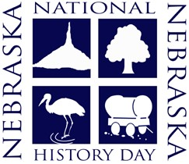

Nebraska National History Day is sponsored by the following institutions:

State Competition and
District Competition and
Overall Program
District Program
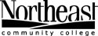
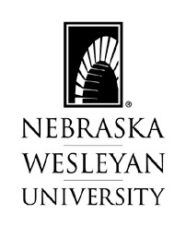
Development

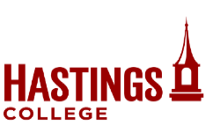
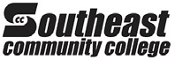

Nebraska

Press
Association
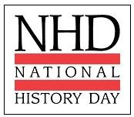
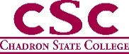

Foundation
THE DF DILLON FOUNDATION
If you are interested in sponsoring the Nebraska National History Day program through scholarships, outreach development, curriculum distribution funds, or some other means, please contact Shari Sorenson at 402-465-2439 or ssorenso@nebrwesleyan.edu.

